The learning mechanisms that underlie children’s prodigious word learning is central to accounts of children’s cognitive and language development. One well-documented learning strategy children employ to learn new words is *disambiguation*: children avoid mapping new words onto objects for which they already have labels, in favor of mapping words onto objects for which they do not yet have labels (Markman & Wachtel, 1988). Although the behavioral pattern of disambiguation is uncontroversial, its underlying mechanism is a matter of debate. In the proposed paper, we will present studies that shed light on the nature of disambiguation by asking whether children exhibit disambiguation not only in the verbal domain, but also in the symbolic gesture domain, a domain in which many word learning phenomena generalize early in language acquisition (e.g., Namy & Waxman, 1998).

***Experiment 1***

18-month-old infants (N= 32) viewed pairs of objects that included one familiar (e.g., spoon) and one novel object (e.g., a garlic press). In target trials, an experimenter asked children to select the referent of a novel symbol (either word or symbolic gesture, depending on condition). Infants also completed preference control trials.

As expected, infants in the word condition selected novel objects more often in target trials (*M=* .61) than control trials (.46), and also more often than predicted by chance (.50). In contrast, infants in the gesture condition selected novel objects *less* often in target trials (.40) than in control trials (.54), and less often than predicted by chance (see Figure 1). This outcome indicates that infants reliably mapped novel gestures to *familiar* rather than novel objects. Disambiguation of novel words was positively correlated with productive verbal vocabularies, *r* = .57, *p* < .05. Disambiguation of novel gestures was not correlated with verbal vocabularies, *r* = .29, *p* >.10

***Experiment 2***

18-month-olds (N= 32) viewed pairs of novel objects. Infants first learned a novel label (either word or gesture) for one object and then completed the disambiguation task, selecting the referent of a second novel label from the same modality as the first novel label.

As expected, infants in the word condition selected unlabeled objects more often in target trials (.63) than control trials (.46) and more often than predicted by chance. Infants in the gesture condition selected unlabeled objects *less* often in target trials (.44) than control trials (.59) but did not differ from chance responding (see Figure 2). Verbal disambiguation was positively correlated with verbal vocabulary levels, *r* = .54, *p* < .05, but gestural disambiguation was not, *r* = -23, *p* >.10

***Conclusion***

18-month-olds reliably mapped novel words onto novel objects or unlabeled objects. In contrast, infants mapped novel gestures onto familiar or previously labeled objects. Although these data are consistent with a domain-specific account of disambiguation, that verbal disambiguation was positively correlated with verbal vocabularies suggests a role for experience in disambiguation. Thus, disambiguation may be better described as a general mechanism that emerges in specific domains as a function of experience within those domains.

***Figure 1****: Mean proportion choosing novel object as a function of trial type and condition (n = 16 per condition)*

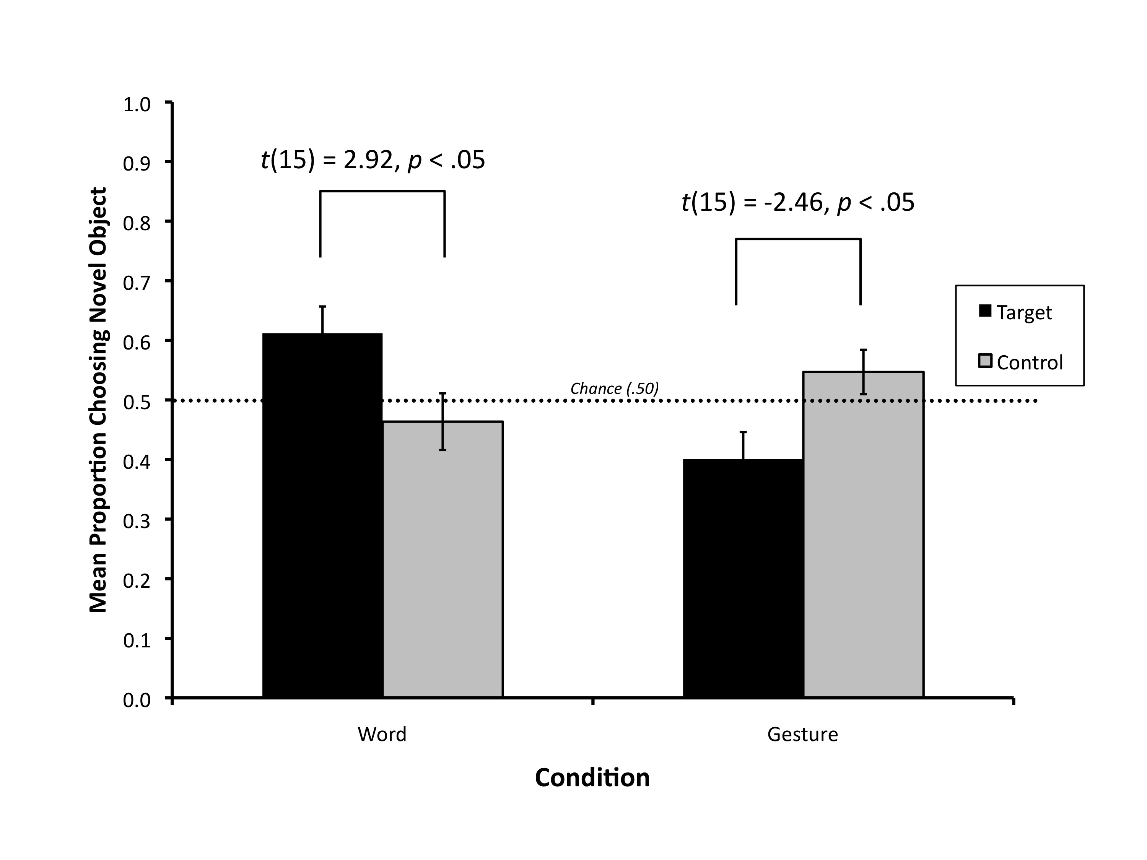

***Figure 2****: Mean proportion choosing unlabeled object as a function of trial type and condition (n = 16 per condition)*

